Virtual Data Analyst Internship
Week 2 Report
Data Visualization and Insight Communication using R
Sample Dataset: Titanic Dataset (Public Dataset)

1. Objective
The objective of Week 2 is to use R-based visualization techniques to explore the Titanic dataset and communicate important patterns and relationships clearly. The analysis uses the Titanic dataset to create informative visualizations and communicate important patterns, relationships, and trends, multiple visualizations are created to examine passenger characteristics, survival patterns, and relationships between numerical and categorical variables. The analysis uses R visualization techniques to present trends, distributions, comparisons, and relationships in a clear and understandable manner.

2. Dataset Overview
The Titanic dataset contains 891 passenger records and 10 original variables.
Attribute | Details
Dataset | Titanic
Records | 891
Variables | PassengerId, Survived, Pclass, Name, Sex, Age, SibSp, Parch, Fare, Embarked
Main outcome variable | Survived
Data type | Numerical and categorical variables

The dataset is suitable for visualization because it contains demographic information, passenger-class information, fare information, and survival outcomes. These characteristics allow different visualization techniques to be applied to examine comparisons, distributions, and relationships within the data.

3. Visualization Design
Different visualization types were selected according to the characteristics of the variables and the analytical questions being examined.
3.1 Bar Chart – Survival by Passenger Class
A bar chart was selected to compare the number of surviving and non-surviving passengers across different passenger classes. This visualization makes categorical comparisons easy to understand.
library(ggplot2)
ggplot(data, aes(x = factor(Pclass),
fill = factor(Survived))) +
geom_bar(position = "dodge") +
labs(
title = "Survival by Passenger Class",
x = "Passenger Class",
y = "Number of Passengers",
fill = "Survival"
)
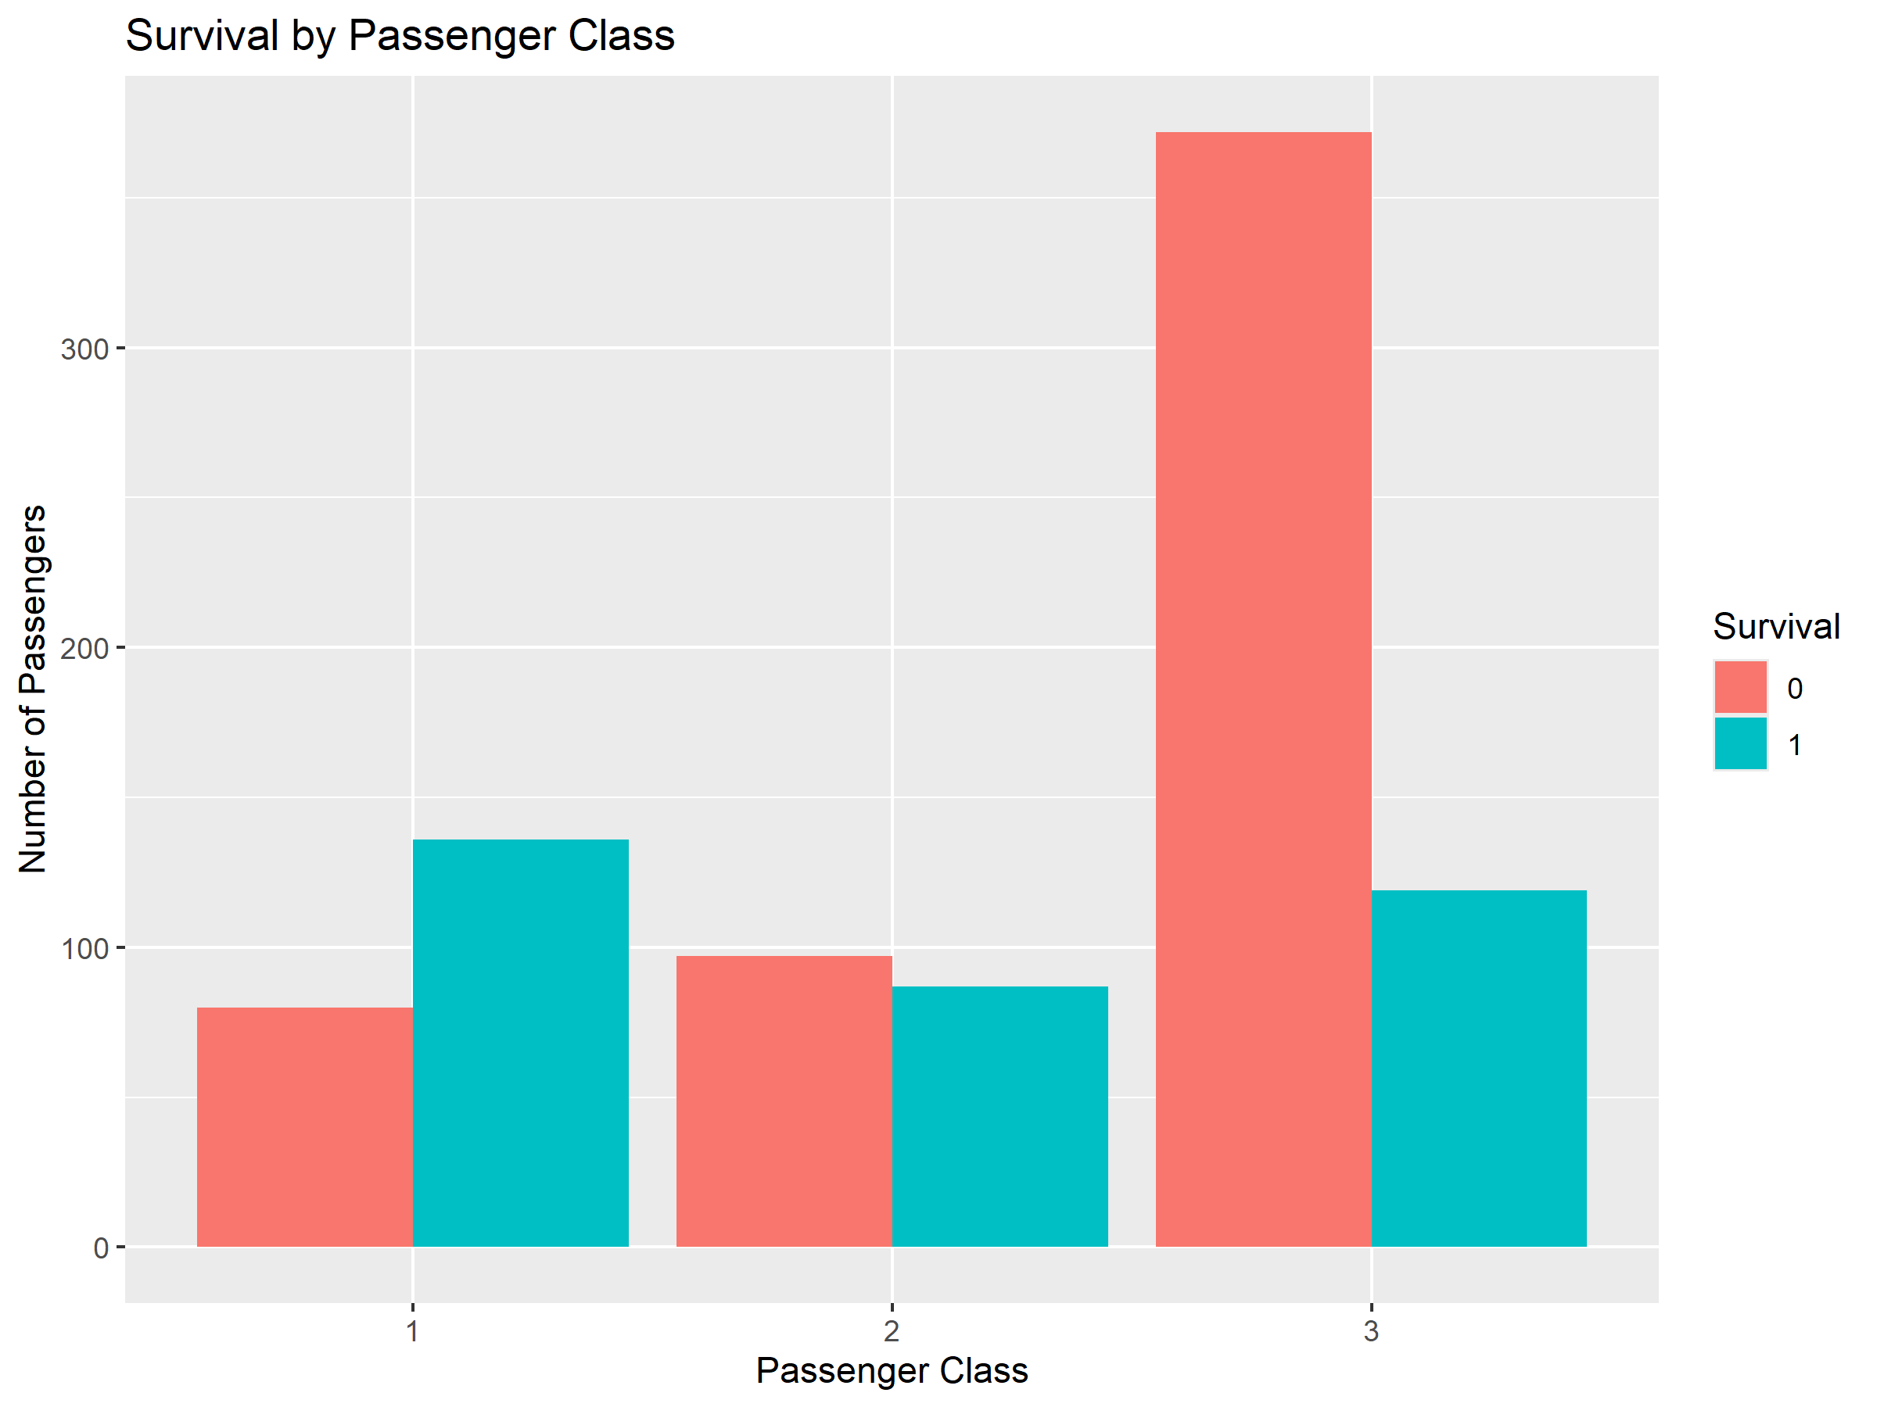
Output:

Interpretation
The bar chart allows comparison of survival outcomes across first-, second-, and third-class passengers. It shows that survival outcomes differed between passenger classes, with passenger class being an important variable for further analysis.
The visualization was selected because a grouped bar chart provides a direct comparison between categorical groups and their survival outcomes.

3.2 Histogram – Distribution of Passenger Age
A histogram was used to examine the distribution of passenger ages.
ggplot(data, aes(x = Age)) +
geom_histogram(bins = 30) +
labs(
title = "Distribution of Passenger Age",
x = "Age",
y = "Frequency"
)
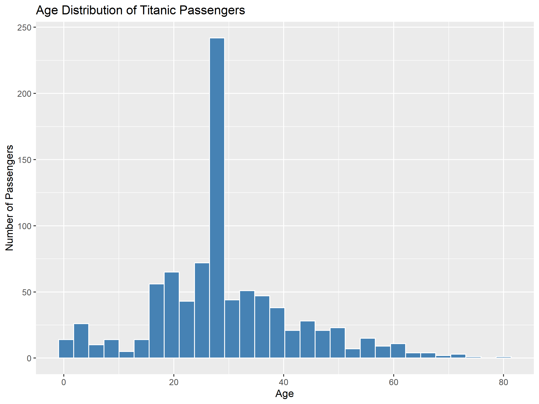
Output Graph:

Interpretation
The histogram shows how passenger ages are distributed across the dataset. It provides an overall view of the concentration and spread of passenger ages and helps identify the age ranges containing the largest number of observations.
A histogram was selected because it is appropriate for examining the distribution of a continuous numerical variable.

3.3 Scatter Plot – Age and Fare Relationship
A scatter plot was used to examine the relationship between passenger age and fare.
ggplot(data, aes(x = Age, y = Fare)) +
geom_point(alpha = 0.5) +
labs(
title = "Relationship Between Age and Fare",
x = "Age",
y = "Fare"
)
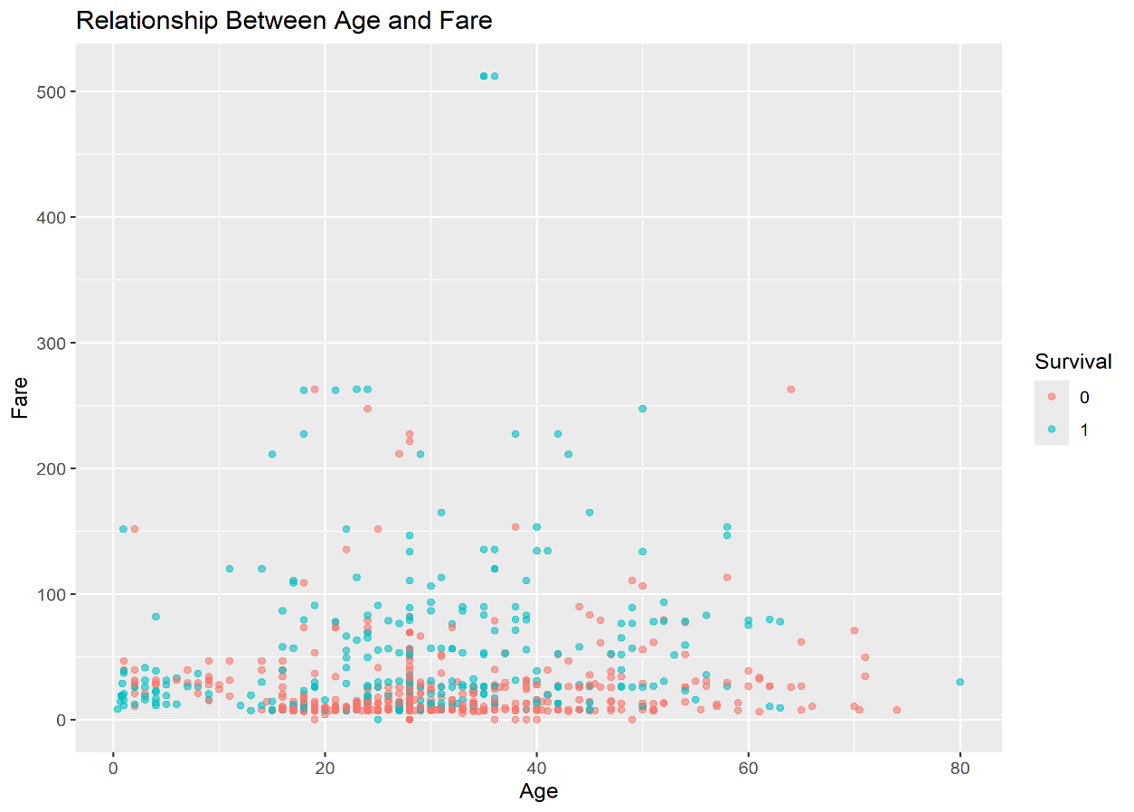
Output Graph:

Interpretation
The scatter plot provides a visual representation of the relationship between passenger age and fare. The points show how fare values are distributed across different passenger ages and help identify whether a clear linear relationship exists.
The scatter plot was selected because it is suitable for examining the relationship between two numerical variables and can also reveal unusual observations.

3.4 Line Chart – Survival Rate by Passenger Class
A line chart was used to display the survival rate across passenger classes.
survival_rate <- aggregate(Survived ~ Pclass,
data = data,
FUN = mean)
ggplot(survival_rate,
aes(x = Pclass, y = Survived)) +
geom_line(group = 1) +
geom_point() +
labs(
title = "Survival Rate by Passenger Class",
x = "Passenger Class",
y = "Survival Rate"
)
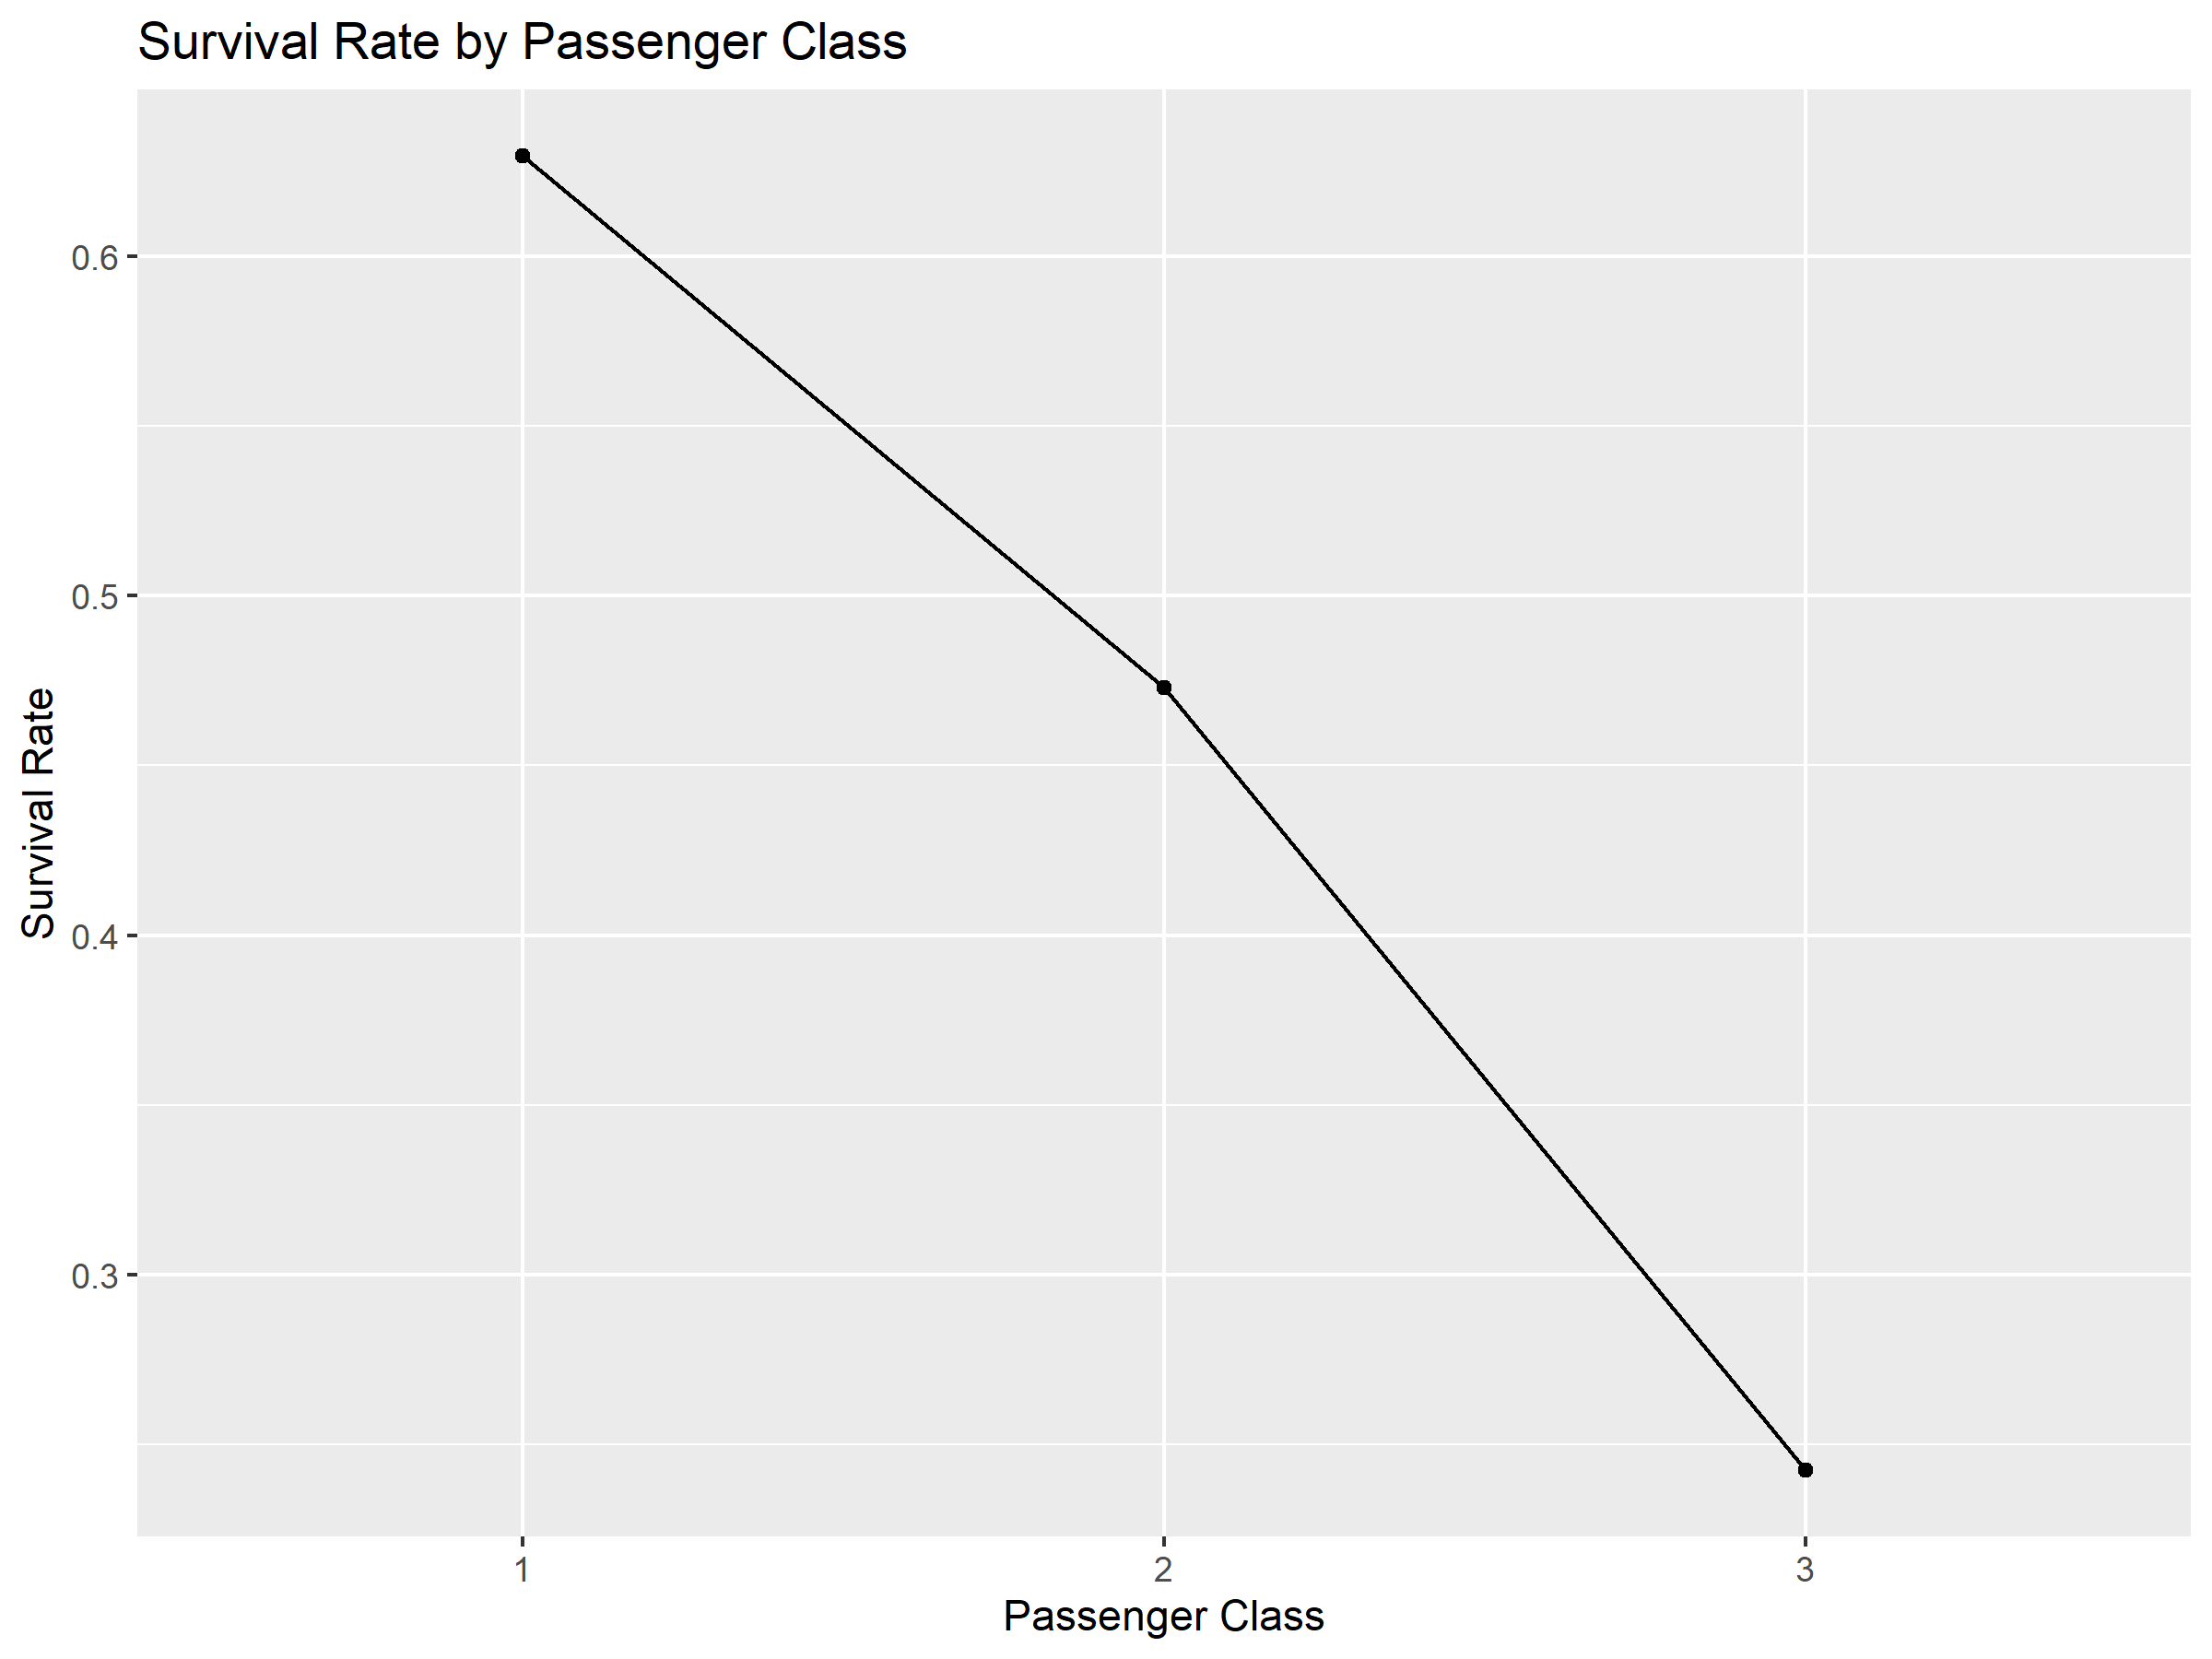
Output Graph:

Interpretation
The line chart shows how the average survival outcome changes across passenger classes. Since Survived is coded as 0 and 1, its mean represents the proportion of passengers who survived within each class.
The visualization makes the difference in survival rates between passenger classes easy to observe and provides a concise representation of the overall pattern.

4. Visualization Output and Evidence
The graphs generated from the R code were included in the report as visual evidence of the analysis.
The visualizations provide four different perspectives of the Titanic dataset:
- The bar chart compares survival outcomes across passenger classes.
- The histogram shows the distribution of passenger ages.
- The scatter plot examines the relationship between age and fare.
- The line chart summarizes survival rates across passenger classes.
Each visualization was selected based on the type of variables being examined and the type of comparison or relationship that needed to be communicated.

5. Key Insights
The visual analysis produced several important observations from the Titanic dataset.
- Passenger survival outcomes varied across passenger classes.
- Passenger age was distributed across a broad range, with a greater concentration of passengers in certain age groups.
- Fare values showed substantial variation among passengers.
- The relationship between age and fare was not represented by a simple strong linear pattern.
- Survival rates differed noticeably across passenger classes.
- Passenger class provides an important variable for understanding survival patterns in the dataset.
These findings provide an initial visual understanding of the dataset and demonstrate how visualization can be used to identify and communicate important patterns.

6. Communication of Insights
The visualizations were designed to communicate the analysis to both technical and non-technical audiences. Simple chart types were selected so that the main patterns could be identified without requiring advanced statistical knowledge.
The bar and line charts make comparisons between passenger classes straightforward, while the histogram provides an overview of age distribution. The scatter plot provides a visual method for examining relationships between numerical variables.
Using appropriate titles, axis labels, and descriptions improves the readability of the graphs and helps the audience understand the significance of each visualization.

7. Conclusion
Week 2 focused on using R visualizations to explore and communicate patterns within the cleaned Titanic dataset. Four visualization techniques—bar charts, histograms, scatter plots, and line charts—were used to examine survival outcomes, passenger age distribution, numerical relationships, and survival rates across passenger classes.
The visual analysis demonstrated that passenger class is associated with noticeable differences in survival outcomes, while passenger age and fare show considerable variation across the dataset. The visualizations provided a clear and accessible way to communicate these observations and demonstrated the usefulness of R for presenting data-driven insights.

